教学设计
课题 | book 4 unit 3 A Taste of English Humor  A Master of Nonverbal Humor | 课型 | reading
教学目标 | 1. enable students to spot the punchline of a joke and get to summarize different forms of English and Chinese humor.  2. help students to use scanning and skimming methods to improve their reading skills and pick up speed in reading.  3. promote ss to appreciate English humor and admire Chaplin as a hardworking idol.
重点 | 1. get a whole picture of whole life of Charlie Chaplin.  2. Learn about nonverbal humor through the introduction to Chaplin.
难点 | Enable students to skillfully apply the skimming and scanning skills.
学情分析 | Students have been familiar with the procedure of reading.  Ss have great interest in exploring the master of nonverbal humor.
教具课件 | - a computer 2. A projector 3. A full set of slides
教法 | Cooperative/ task-oriented/ independent thinking
教学程序 | Warming up  Pre-reading  While reading  Post-reading |  |  | 师生  活动 | 时间分配
Step 1  Step 2  Step 3  Step 4  Step 5 | Warming up (discussion & brainstorming)  1.Enjoy the following jokes and find out the punchline of each one.  Tom: Mom, can I have two pieces of cake, please?  Mom: Certainly -- take this piece and cut it two!  Punchline is usually the last few words of a joke that make it funny.  2.How many kinds of humor do you know?  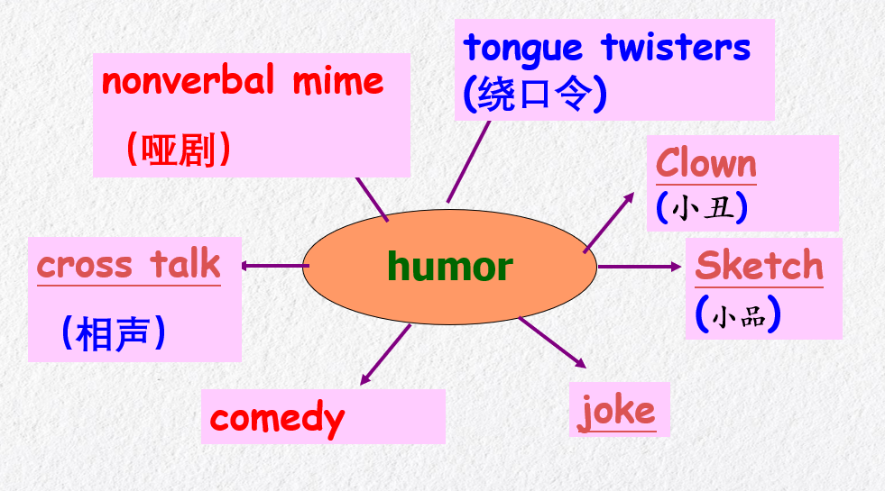  - What kind of humor may these persons remind you of?  Pictures of some famous humor actors will be given for Ss to categorize and get them to different forms of humor. (Charlie Chaplin is included therein)  Pre-reading (prediction)  1. What do you know about Charlie Chaplin?  Some basic information of him will be displayed and also his masterpieces listed.  2.according to the title of the passage, Chaplin’s type of acting is ____.  A. comedy B. cross talk C. mime D. sketch  While-reading  Skimming  3. When was he born and when did he die?  A. 1889-1972. B. 1889-1977.  C. 1886-1972. D. 1886-1989.  4. What’s the main idea of the text?  A. The history of English humor.  B. How Chaplin entertained the audience with his humor.  C. a brief introduction to Charlie Chaplin.  D. The Gold Rush in California.  5. Match the main idea of each paragraph  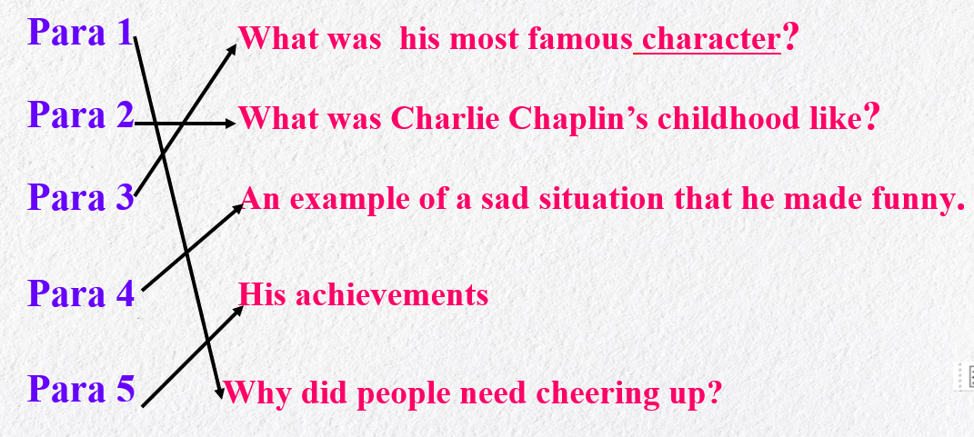  Scanning  1) Paragraph 1  a. Why people needed cheering up?  Background：two world wars; hard years  People felt depressed  b. How did Charlie Chaplin help people?  He brightened the lives of people.  They could feel content with their lives.  Key point: A hero is nothing but the product of his time.  2) Paragraph 2  True or False  1. Charlie was born in a rich family.  2. His parents were both popular stars.  3. He could mime and act the fool doing ordinary everyday tasks.  4. His unskilled acting made people feel boring.  3) Paragraph 3  What is the little tramp look like?  What is the costume Chaplin need for acting this character?  What made the little tramp loved by people?  4) Paragraph 4  Watch the video then use “First,--- Then,--- Finally” to describe his actions.  1. First, he _________the laces and eats them.  2.Then, he _______the leather top of the shoe.  3.Finally, he __________and ________ the bottom of the shoe.  This paragraph states a vivid description of his eating shoes as a splendid meal.  5) Paragraph 5  What did he do for the films he starred in?  What is the most eye-catching achievement of him?  What influence did he leave on people?  Post-reading  Retelling & filling blanks  As an outstanding humor us actor Charles chaplin (bright) the lives of Americans and British during the period of silent films. He made people (laugh) at a time when day felt depressed. So they could feel more content (with) their lives.  His charming character, the little tramp, was well known all over the world. The Trump was a poor and (home) man wearing large trousers, worn out shoes a small round black hat and (carry) a walking stick. Social failure as the little Trump was, he was loved by all people for his optimism and determination (overcome) all difficulties and being kind to other even when day were UN kind to him into films in a famous film de gold rush Chaplin managed (make) the sad situation--- eating a boiled shoe (entertain) by using non-verbal humor.  such is telling Charlie Chaplin, loved and remembered as a great actor could inspire people with great confidence.  Homework  independently explore the language points therein and sketch the pattern of personage introduction. |  |  | Listen  Do exx  Read & do exx | 1’  2’  1’  3’  6’  5’  5’  5’  5’  2’  4’  1’
板书 | Unit 3 A Taste of English Humor  The 3rd Period Reading  Warming up: brainstorm  Pre-reading: prediction  While-reading: skimming & scanning  Post-reading: consolidation

2020.6. 28

