Unit 5 Do you want to watch a game show? Section B (2a-2e)
Shaanxi Normal University Yangling Experimental Middle School
Zhang Li
Teaching objectives:
By the end of this class, students will be able to:
- learn to get personal information of Mickey through scanning and skimming the passage.
- master some important words by describing Mickey and other symbols of Chinese cartoon .
- develop a positive attitude when meeting something unlucky by analyzing Mickey’s spirit.
Teaching Key and Difficult points:
- How to help students practice the reading skills to get the information of Mickey.
- How to understand the spirits of Mickey correctly.
Step 1 Lead-in
- Greetings as usual.
- Show a picture of Shanghai Disneyland and ask students to guess where is it.
- Show students some cartoons of Disneyland and ask students to give more examples.
Step 2 Guessing Game
Do a quiz to check students hoe much do they know about Mickey.
Step 3 Reading
Activity 1 Skim and match the main idea of each paragraph.
Para. 1 The success of Mickey Mouse
Para. 2 An introduction of Mickey Mouse
Para. 3 The reason why Mickey Mouse is so popular
Activity 2 Complete the resume of Mickey Mouse
Resume of Mickey Mouse（米奇的简历）
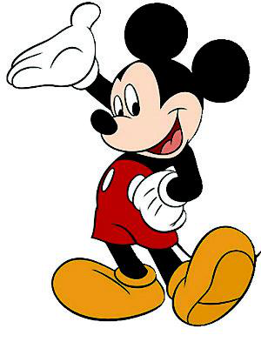  Personal information  （米奇的个人信息） | Name | Mickey Mouse | Birthday | 1928
 | Nationality | American | Age | 92
 | Appearance  （外表） | He is a black mouse. He has two round ears.  He wears red clothes and yellow shoes.
Mickey’s life  Experiences（米奇的生活经历） | In 1928: Mickey first appeared in the cartoon Steamboat Willie.  In the 1930s：Walt Disney made 87 cartoons with Mickey.  In 1978: Mickey became the first cartoon character to have a star on the Hollywood Walk of Fame.

Step3 Group Work (Let’s write)
There are many cartoon characters at home and abroad. which one do you like best? Discuss with you group members.
Refer to the sentence patterns
I like Mu lan very much.
Because she takes her father's place to fight in the army.
What's more, she is very brave.
We can learn many things from her.
such as her kindness and her love to her father.
Step 4 Summary
He’s not only a cartoon but also the spiritual support of a generation.
Step5 Homework
- Write the most beautiful cartoon character in your heart and send it to your school station.
- Find out more meanings behind the cartoon characters on the Internet.

